***L.Smith’s 3rd Grade Supply List***

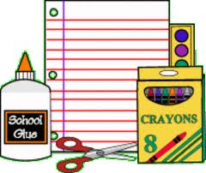

□2 Headphones or Ear Buds ***(REQUIRED) Please mark with name.***

□1 pack notebook paper- wide Rule

□2 plastic two pocket folders (1 yellow, 1 any color)

□1 Pencil pouch

□4 spiral notebooks or composition notebooks

□2 boxes of crayons

□4 packs of pencils

□1 bottle of glue or pack of glue sticks

□1 pair of scissors

□2 packs of dry erase markers- black

□1 pack of index cards

□1 box of markers and/or colored pencils (optional)

Donations of the following items will be greatly appreciated:

* Kleenex tissue boxes
* Paper lunch bags
* Hand sanitizer/hand soap
* Cleaning wipes (Clorox wipes or baby wipes)
* Ziploc bags (all sizes)
* Paper towels

**\*Please label all items with your child’s name before bringing them to school. We will also need household items throughout the year, such as paper towel tubes, toilet tissue tubes, shoe boxes, and empty plastic containers for projects.**